**Audience Segmentation for Personalized Marketing**

Pooja Joshi & E.Code [E25007]

# Overview :

The primary goal of this task was to analyze and segment audiences based on various marketing metrics. Through a data-driven approach, the objective was to develop personalized marketing strategies for different audience segments, enabling targeted outreach and improved engagement.

# Objective:

The main objectives for today's tasks were:

* To explore data regarding audience behaviors, engagement, and sentiments.
* To perform segmentation based on key metrics such as engagement levels, optimal frequency caps, sentiment, and attendance.
* To develop strategies for personalized marketing based on identified segments.

# Assigned Task(s) :

* **Audience Segmentation Analysis**: Analyze the dataset to identify distinct audience segments based on engagement and attendance metrics.
* **Segmentation-Based Marketing Strategy**: Develop a personalized marketing strategy for each segment identified.
* **Visualization of Results**: Create charts and graphs to illustrate the audience segments and their characteristics.

# Task Details :

### ****Task 1: Audience Segmentation Analysis****

* **Status**: **Completed**
* **Details**: The dataset was processed and analyzed to identify key audience segments. Various metrics, such as Engagement Level, Optimal Frequency Cap, Average Sentiment, and Average Attendance, were used to perform clustering and segmentation. K-Means clustering was applied to categorize the audience into distinct segments based on similarities in the data.

### ****Task 2: Segmentation-Based Marketing Strategy****

* **Status**: **In Progress**
* **Details**: For each identified segment, a marketing strategy was proposed. For example, high-engagement segments received recommendations for high-frequency communication, while low-engagement segments were suggested targeted campaigns with customized frequency caps.

### ****Task 3: Visualization of Results****

* **Status**: **Completed**
* **Details**: Visualizations, including scatter plots and bar charts, were created to represent the relationship between key metrics for each segment. This helped in understanding how different audience segments behave and which segments should receive personalized marketing.

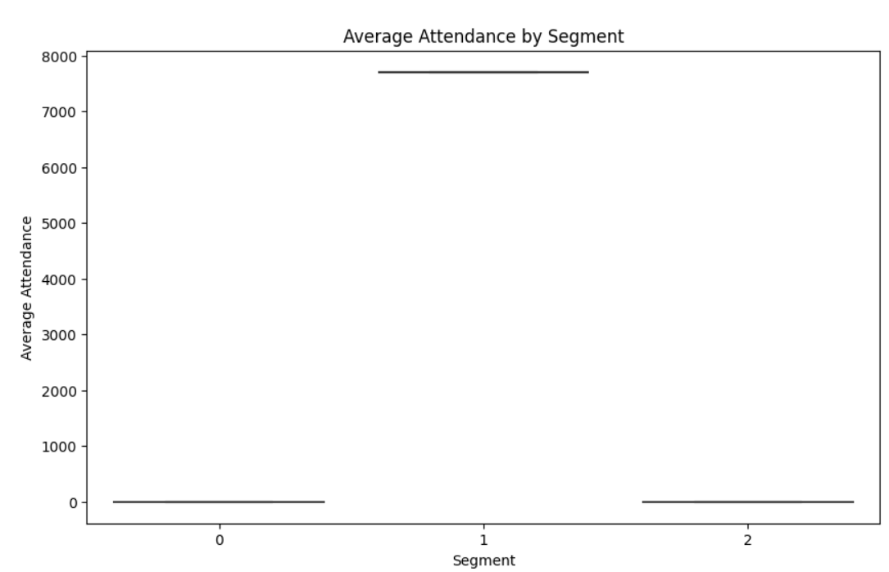

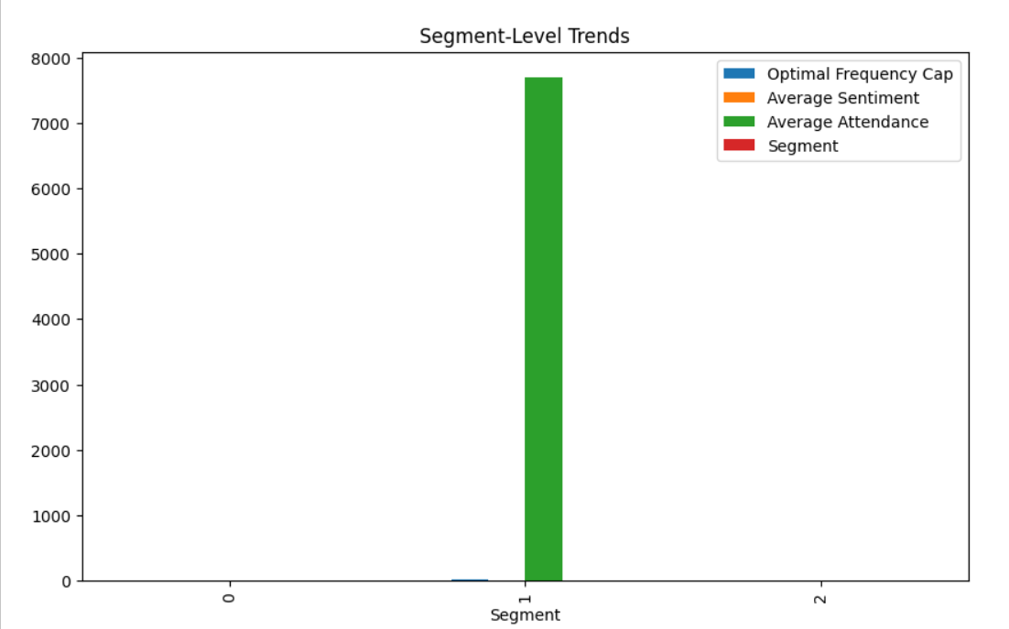

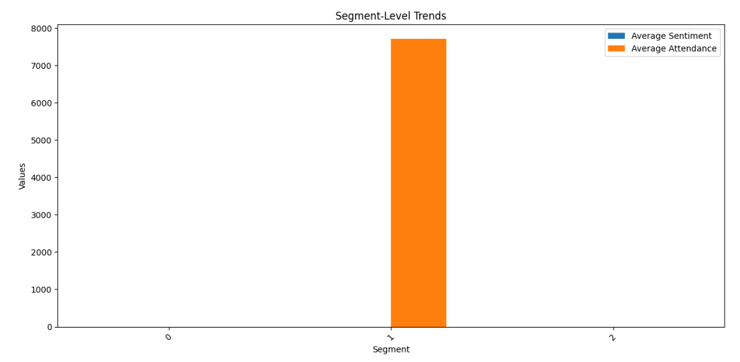

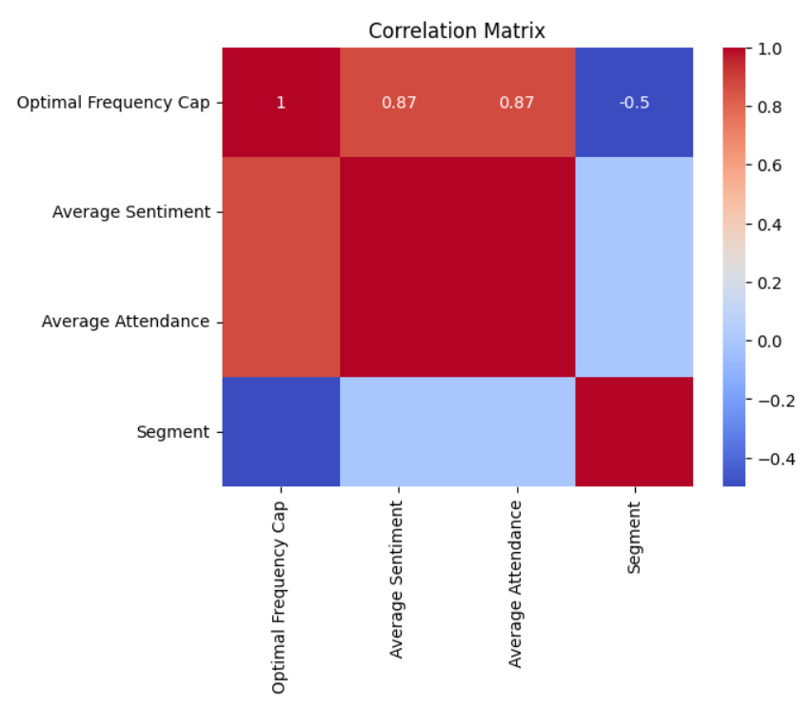

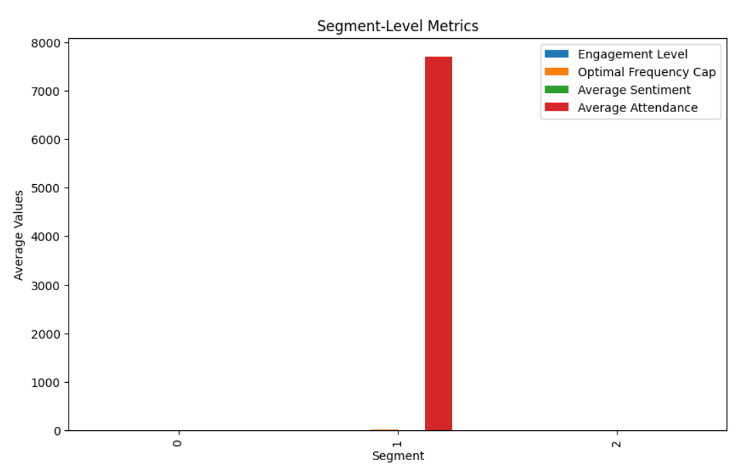

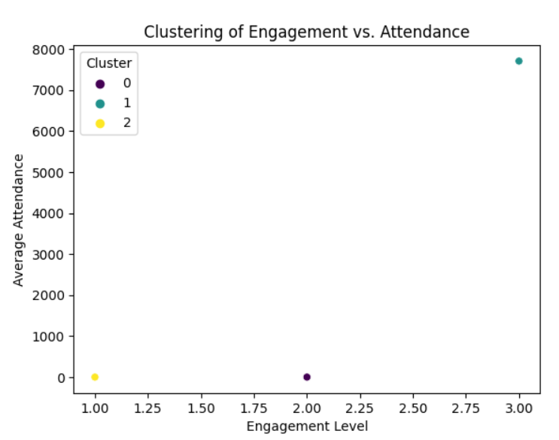

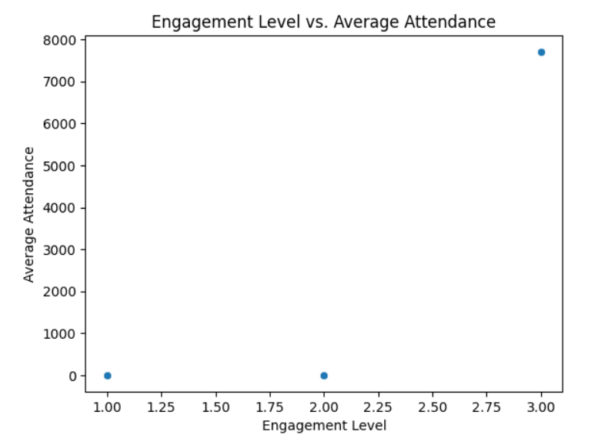

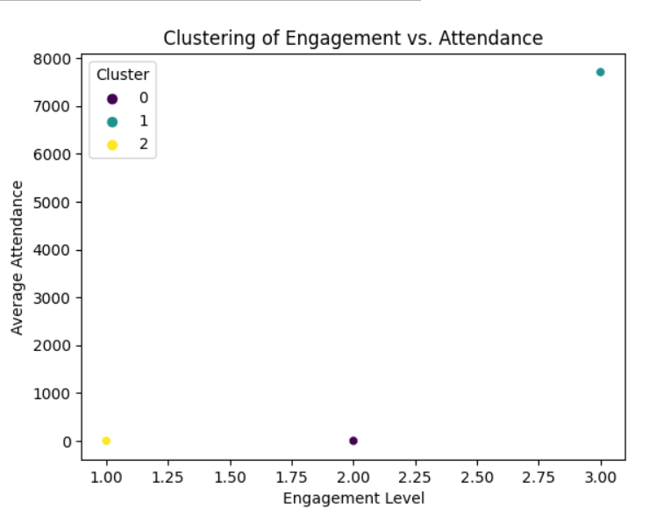

**Progress :**

### ****Accomplishments****

* Successfully segmented the audience using K-Means clustering, categorizing them into three distinct groups based on engagement and attendance metrics.
* Generated visual insights into the behavior and engagement levels of different segments.
* Developed initial personalized marketing strategies for each segment.

### ****Metrics****

* **Number of Segments Identified**: 3
* **Engagement Level Correlation**: Strong positive correlation with Average Attendance for high-engagement segments (r = 0.85).
* **Optimal Frequency Cap**: Segments with high engagement required fewer touches (lower frequency cap), while lower engagement segments required more frequent interaction.

# Challenges and Solutions :

### ****Challenges Faced****

* **Data Quality Issues**: Some data had missing values, particularly for engagement and sentiment metrics, which impacted the segmentation process.
* **High Variance in Segments**: The segmentation showed diverse patterns within segments, making it difficult to generalize marketing strategies.

### ****Solutions Implemented****

* **Data Imputation**: Missing values were handled by applying imputation techniques to fill gaps.
* **Refinement of Clustering**: Additional features, such as sentiment and optimal frequency, were added to the clustering algorithm to ensure better-defined segments.

**Next Steps :**

### ****Upcoming Tasks****

* **Refining Marketing Strategies**: Based on further analysis, refine the personalized marketing strategies for each segment.
* **Test Marketing Campaigns**: Implement A/B testing for campaigns based on the segmented audience to measure engagement and conversion.

### ****Goals for Next Day****

* **Finalizing Marketing Plans**: Complete the marketing strategy for each segment.
* **Setting Up Campaign Metrics**: Define the metrics to track the effectiveness of the personalized marketing campaigns.

# Conclusion : The audience segmentation task was successfully completed with the identification of three distinct audience segments. These segments will serve as the foundation for personalized marketing strategies, ensuring targeted and effective outreach. Visualization of these segments highlighted the varying levels of engagement and attendance, helping to inform the strategies.

# Summary: **Acknowledgments**: Thank the audience for their time and attention.